# Report 1

This report includes updates and progress report for Tas1 and definition of Task 2.

## Scope

|  |  |  |
| --- | --- | --- |
| **Tasks:** | **Task Goal/ Desired outcome** | **Progress** |
| Task 1 | **PCR data management**  Extracting the data in (.csv) from original PCR results file(.eds) | Quant-Studio 5: Completed |
| Quant-Studio 7: In progress |
| Other instruments: On-hold |
| Task 2 | **GS-Call data work-flow**  *Goal:*  This task aims to put the PCR result data into a proper format for further analysis in GS-Call software.  *Desired outcome:*  The application should open up in the web browser and take the user input info, then generate a specific formatted (.csv) file containing the information of samples/targets to be imported on the PCR machine by the user. | 1. Developing the code: 50% done 2. Working on panel design: later |
| 1. Deploying the app |
| 1. Developing a data base in SQL and connecting that to the app |
| 1. Deploying the app with SQL database |
| :D more challenges to come |

## Task 2 progress:

***Current work-flow:***

The main idea of task 2 has been originated from a macro program developed by Angela in Microsoft Excel. The macro is used by the user to put the information for each well of 384 well plate in an excel sheet and then generates a (.csv) file containing all the information in a proper format (see Figure 1 bellow):

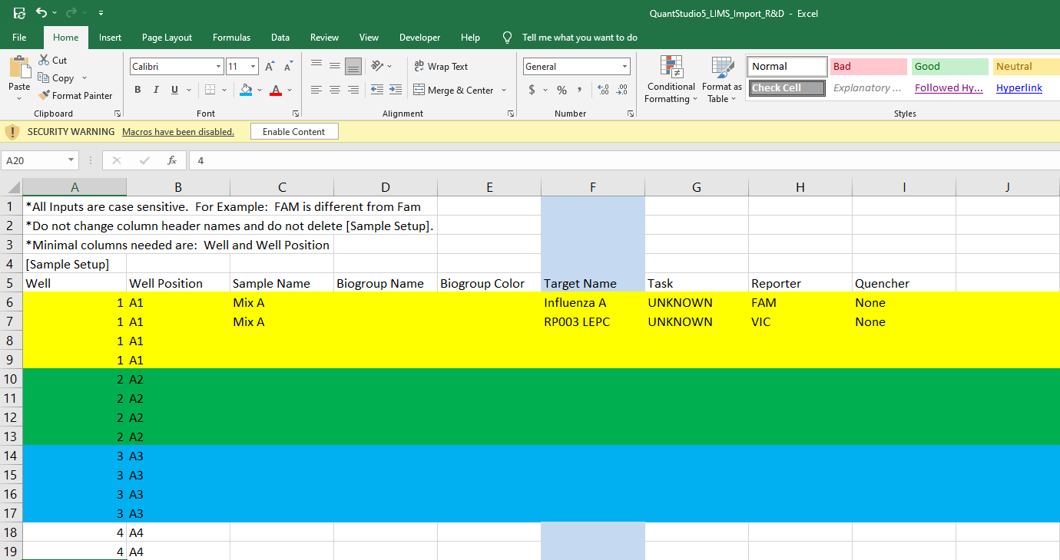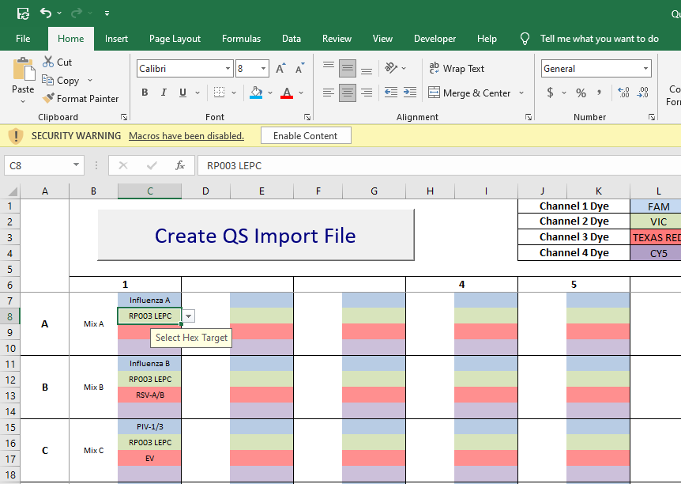

1. Input info to the macro
2. Input info to the macro

**Figure 1: The input information on the excel sheet for each well (a). The macro takes the input from the excel sheet and generates the result (.csv) file on the right-hand side to be imported on PCR machine by the user (b).**

***Web-based application:***

We take the same idea and implement it in a web-based application. As suggested by Angela we want to improve and simplify the system by using a more generalized formatting for the input information. To put it simply, the app takes the minimum input from the user and generates the (.csv) for them to import it on PCR machine.

The application asks user to select the kit/product and the sample names/numbers this information is enough to generate the (.csv) file for the user to download it from the app (see Figure 2 bellow).

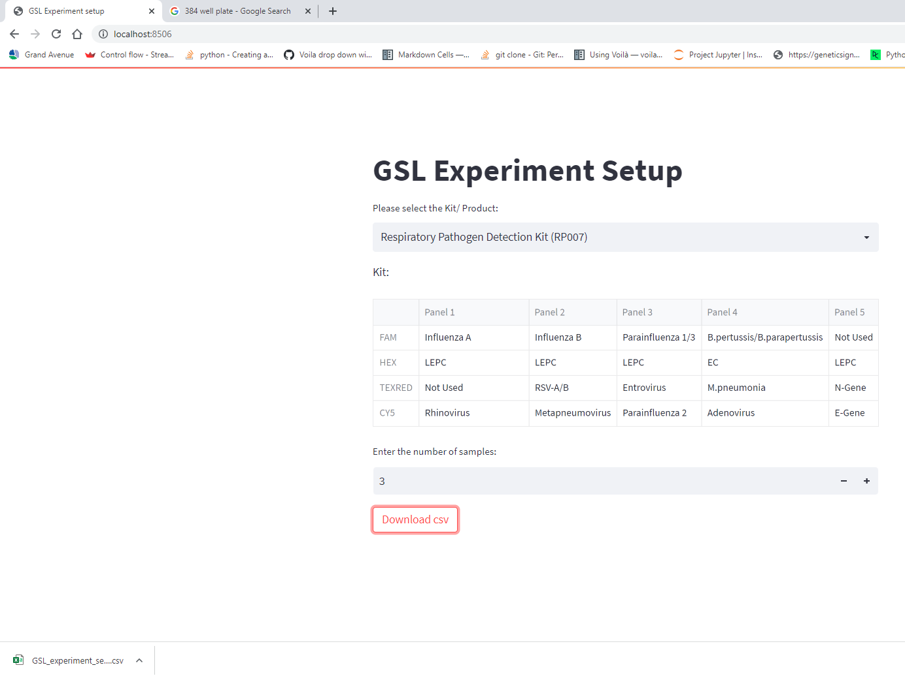**Figure 2: Preliminary view of the app (GSL experiment setup). The users are asked to select the kit/product, then the standard panels within the kit will be shown just to check. Then, they specify the number (*Name) of samples per plate. And then they can download the (.csv) file. The generated (.csv) file has the same format as figure 1-b.**

*(I would include the option to takes the samples “Names” as well).

This is the basic concept of the app and how it works hopefully. Please note that the (.csv) result file of the app has not been completed yet to be shown in Figure 2.